GEFERTEC successful in Asia

Berlin, 13 May 2020 – The new GEFERTEC process for 3D metal printing continues to gain international acceptance. Two 3DMP® machines are currently being supplied to Asia.

MMT Duncha, a member of the MMT Corporate Group based in Pyeongtaek, Korea, recently invested in an arc405. The company, which specializes in the production of high-quality titanium parts for aerospace and general industrial applications, is planning to strengthen its R&D activities in additive manufacturing. Their aim is to replace or supplement the current standard method of milling semi-finished products. MMT General Manager Seok Kyoo Park: "We are convinced that 3DMP® is the most promising concept for additive manufacturing – especially for aircraft parts, where validation is extremely demanding."

A unique development is taking place in the Japanese market, where Mitsubishi Hitachi Power Systems (MHPS) will also be installing an arc405. At its Hitachi site, the company is planning to join forces with GEFERTEC in the field of materials research. Other interested customers in Japan will also have access to the innovative production technique. MHPS will be using the machine to develop and test new materials for gas turbines.

"We have been very successful with current internationalization strategy," says GEFERTEC Managing Director Tobias Röhrich. "Our 3DMP® process developed in-house has enabled to meet the needs of many customers worldwide."

The 3DMP® process used in all GEFERTEC arc machines is based on proven arc welding technology with wire as the starting material. This makes it easier to handle and faster than powder-based 3D printing processes. Wire is available at significantly lower prices for most standard materials.

(1699 characters incl. spaces)

About GEFERTEC
Developed by GEFERTEC, 3DMP® is a new process with groundbreaking possibilities for manufacturing metal components. GEFERTEC is the only company in the world to offer this process with state-of-the-art production machinery. The company is a member of the medium-sized Berlin.Industrial.Group. (B.I.G.) headquartered in Berlin with a workforce of approx. 320 employees.

Images: © GEFERTEC

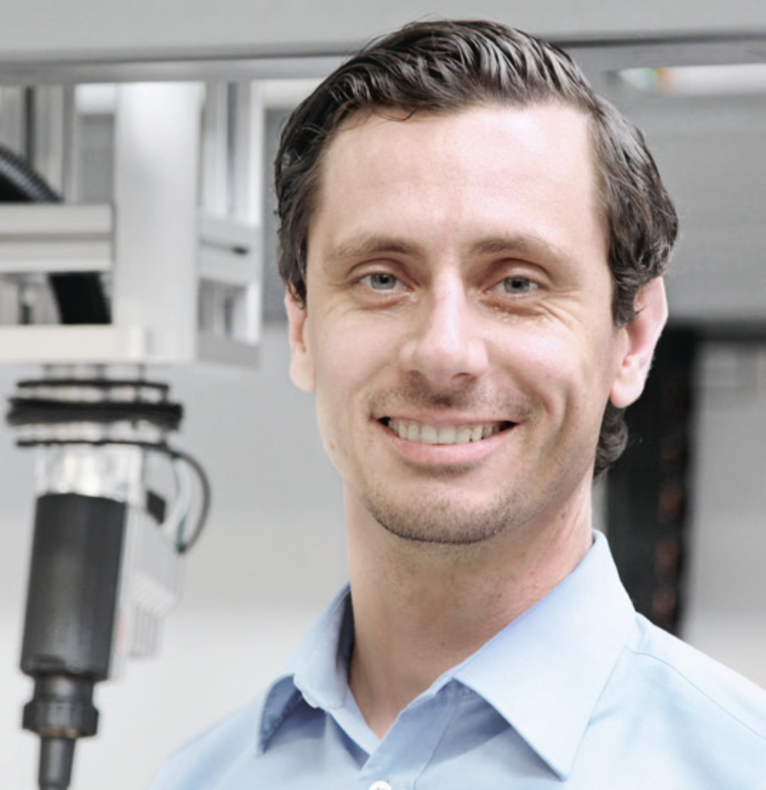
Caption:
Tobias Röhrich, Managing Director GEFERTEC GmbH: "We are currently very successful with our internationalization strategy."

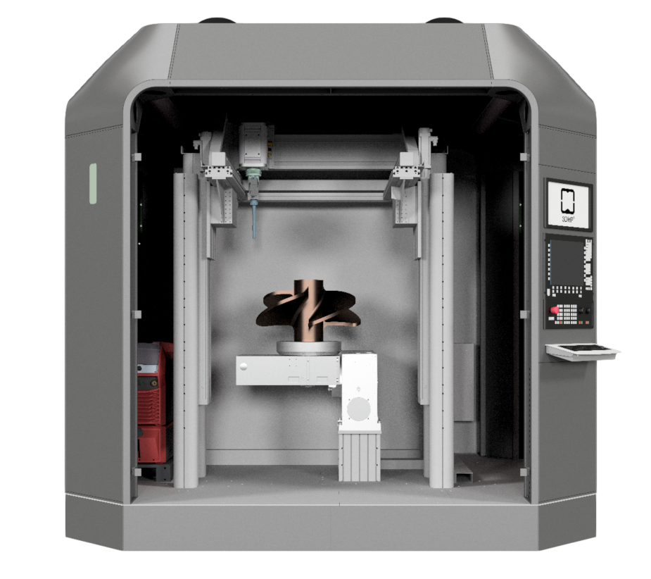
Caption:
Two GEFERTEC arc405 machines are on their way to Korea and Japan to MMT Duncha and Mitsubishi Hitachi Power Systems (MHPS).

Media contact:  Jörg Lantzsch  Agentur Dr. Lantzsch  Panoramastraße 22  65199 Wiesbaden  Tel.: 0611-205 93 71  E-Mail: j.lantzsch@drlantzsch.de  www.drlantzsch.de | Company contact:  GEFERTEC GmbH  Schwarze Pumpe Weg 16  12681 Berlin  Tel.: 030-912074-360  E-Mail: info@gefertec.de  www.gefertec.de

