International research institutes invest in 3D metal printing machines from GEFERTEC

Three 3DMP® machines are currently being supplied to Nanjing University, the Oregon Manufacturing Innovation Center (OMIC) and to the Brandenburg University of Technology.

Berlin, June 6th 2020 – A growing number of university institutes and private research companies are investing in GEFERTEC machines for innovative 3D metal printing. 3DMP® is being used to test new manufacturing techniques and the processing of different metals.

Together with the EMAG subsidiary in China, GEFERTEC is now serving a new customer in the research sector. EMAG, a machine tool manufacturer, is a strategic partner and GEFERTEC minority shareholder. Nanjing University of Aeronautics and Astronautics, in cooperation with its joint venture partner Pukou Advanced Manufacturing Research Institute, has purchased a GEFERTEC arc405 machine for aerospace research projects. The university has its own subsidiary and is involved in technology transfer for this important future industry.

A GEFERTEC arc605 is being installed at the Oregon Manufacturing Innovation Center (OMIC) on the west coast of the USA. As a joint research facility, the OMIC R&D is sponsored by 29 industrial companies, three academic institutions and the state of Oregon. The center supports members with joint manufacturing projects. The arc605 machine will play a key role in the new OMIC Center focused on additive manufacturing. This new center will provide a critical opportunity to develop research in rapid tooling that is critical to some of OMIC R&D’s largest members, including Daimler Trucks North America, LLC. GEFERTEC, through its OMIC R&D membership, will maintain close contact with these members and with potential users of the arc605.
The Brandenburg University of Technology (BTU) Cottbus-Senftenberg will also be using 3DMP® in the future. A GEFERTEC arc605 is being installed at the 3DLAB coordinated by the university’s design and manufacturing department. 3DLAB Cottbus is supported by a state funding program for structural change. It will enable the continuous analysis of process chains in additive manufacturing based on wire or powder, from material production to the tested component. Within collaborative projects, numerous local and national companies already rely on the competencies and the infrastructure of 3DLAB. The 3DMP® technology is an integral element in the field of wire-based additive manufacturing and will be used in new research areas in the future, e.g. for lightweight construction, construction and tool making.

About 3DMP®
The 3DMP® process used in all GEFERTEC arc machines is based on proven arc welding technology with wire as the starting material. This makes it easier to handle and faster than powder-based 3D printing processes. Wire is available at significantly lower prices for most standard materials.

(2,897 characters incl. spaces)

Images: © GEFERTEC

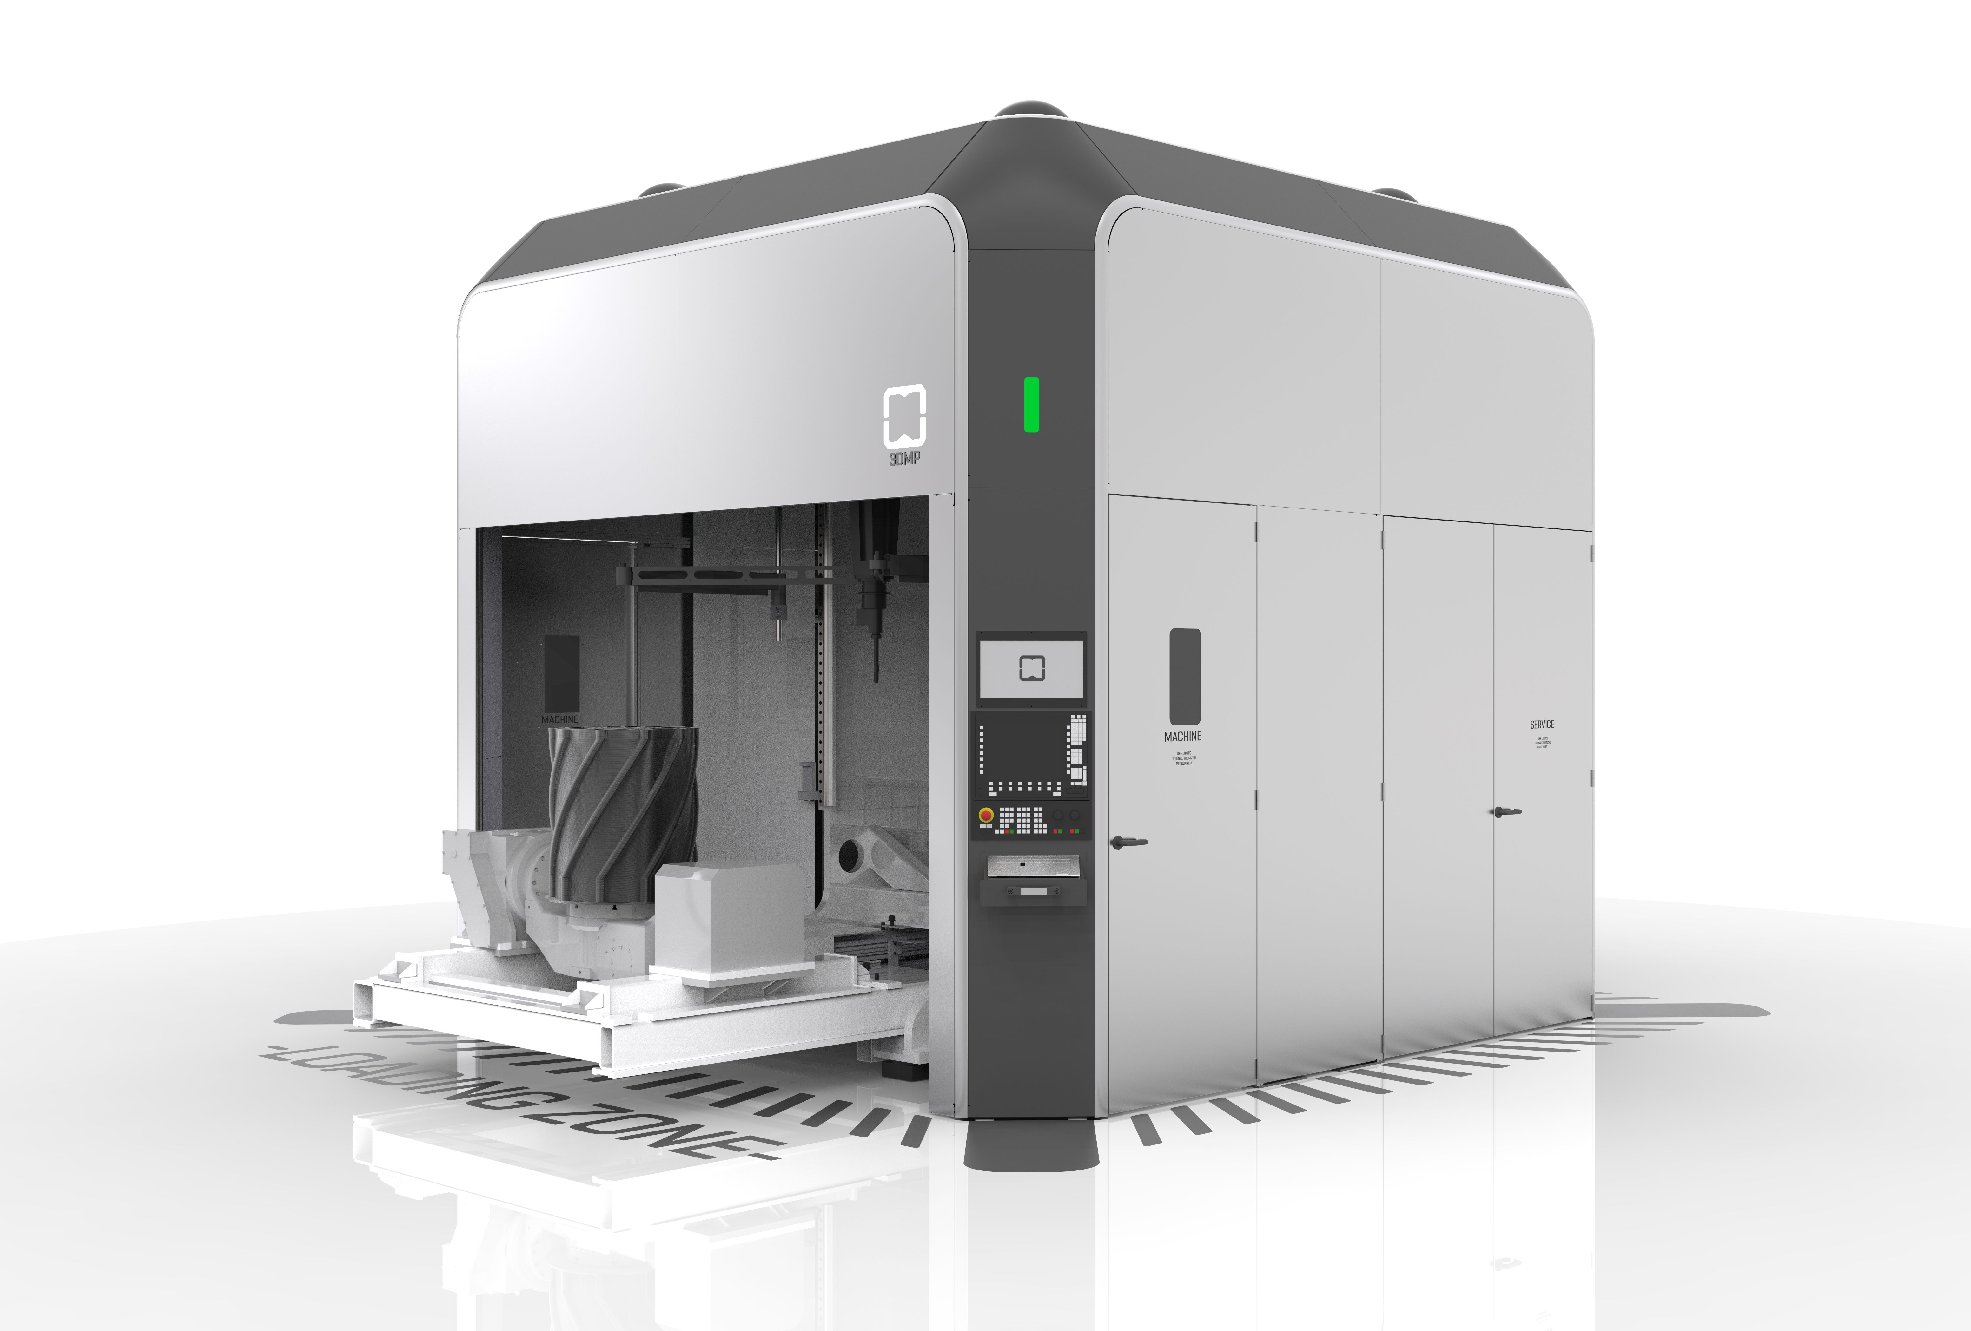
Caption:
The GEFERTEC arc605 is designed for 5-axis machining of components with a volume of up to 0.8m³ and a maximum mass of 500kg. This machine is currently being supplied to OMIC in Oregon and to BTU Cottbus-Senftenberg.

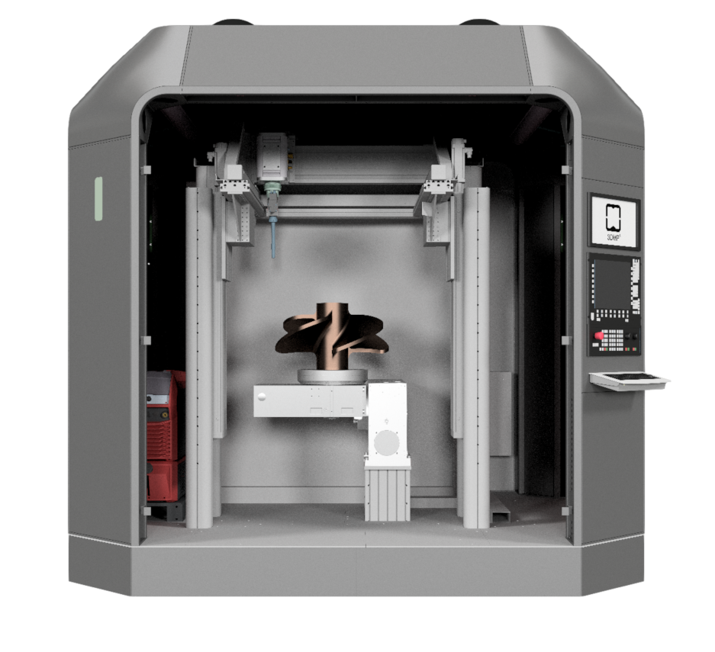
Caption:
A joint venture between Nanjing University of Aeronautics and Astronautics and the Pukou Advanced Manufacturing Research Institute purchased an arc405 for aerospace research projects.

About GEFERTEC
Developed by GEFERTEC, 3DMP® is a new process with groundbreaking possibilities for manufacturing metal components. GEFERTEC is the only company in the world to offer this process with state-of-the-art production machinery. The company is a member of the medium-sized Berlin.Industrial.Group. (B.I.G.) headquartered in Berlin with a workforce of approx. 320 employees.

Publication free of charge. Copy requested.
Media contact:  Jörg Lantzsch  Agentur Dr. Lantzsch  Schwalbacher Straße 74  65183 Wiesbaden  Tel.: 0611-205 93 71  E-Mail: j.lantzsch@drlantzsch.de  www.drlantzsch.de | Company contact:  GEFERTEC GmbH  Schwarze Pumpe Weg 16  12681 Berlin  Tel.: 030-912074-360  E-Mail: info@gefertec.de  www.gefertec.de

