Laser welding with filler wire for even thick materials and wide gaps

The new laser multi-wire technology (LMWT) from Berlin-based SKLT is the first to use lasers to join thick steel or aluminum plates even with gap widths of up to 3 mm – at very high process speeds. This process can also be used very efficiently for surface coating.

Berlin, June 24, 2020 – Berlin-based Strahlkraft Lasertechnik (SKLT) is introducing a new technology for laser joining that can handle even thick steel and aluminum sheets. The process closes a technology gap for laser use with plate thicknesses of up to 10 mm and offers a high-performance alternative to the electric arc process, which has so far been commonly used.
Laser multi-wire technology (LMWT) is based on a proven laser processing head from Berlin-based Scansonic proven in industrial use and refined by SKLT engineers for this application. The principle is as follows: At the process point, several filler wires converge and are simultaneously melted by an oscillating laser beam. This allows seams of up to 10 mm in width to be created in a single operation, depending on the number of filler wires used and the process parameters.
A smart control concept ensures wire drive synchronization and optimum energy distribution at the seam. An auto-focus keeps the spot size constant, even when component position shifts. The new process thus functions smoothly, even under erratic joining conditions.
LMWT expands the list of possible applications for the laser, which is already a highly flexible tool. Among laser joining's advantages are high process speeds and low thermal distortion. But so far, this has required relatively gap-free positioning of the two pieces to be joined. Low gap widths (up to about 1 mm) could be compensated for with a single filler wire. Larger gap widths or thicker plates ruled out the use of a laser, however. The alternative, the electric arc process, is much slower and the thermal distortion greater. LMWT thus has clear advantages over conventional solutions.
New fields of application for automated laser joining
What makes LMWT especially interesting is its usefulness in creating fillet welds at T-joints or lap joints with steel or aluminum materials that require large adhesion widths or seam volumes. "We see a wide range of LMWT applications for users who previously could not enjoy the advantages of the laser," says Carsten Rösler, SKLT's managing director. "Those users certainly include companies that manufacture ships, construction machines, and railway vehicles, companies from steel building and offshore technology, and manufacturers of machine frames and containers." The clear quality advantages of joining aluminum make LMWT an attractive option for battery compartments in electrical vehicles as well. Process developers and research facilities benefit from the tool's flexibility.
An additional, important feature of the new LMWT process is its extreme efficiency in applying individual homogenous layers during surface finishing. All materials available in wire form can be used in such processes.
2740 characters, including spaces (not counting title and introduction)

About SKLT GmbH
The company offers systems and solutions in the areas of laser technology, especially for laser-wire processes. The focus is on additive manufacture, 3D printing, and surface-coating metallic material, and on innovative laser joining concepts. SKLT GmbH is collaborating with Scansonic MI GmbH, whose systems have proven themselves in more than 20 years of industrial use. An ongoing additive process development project is being supported by the European Regional Development Fund (ERDF).

Photos ©: SKLT

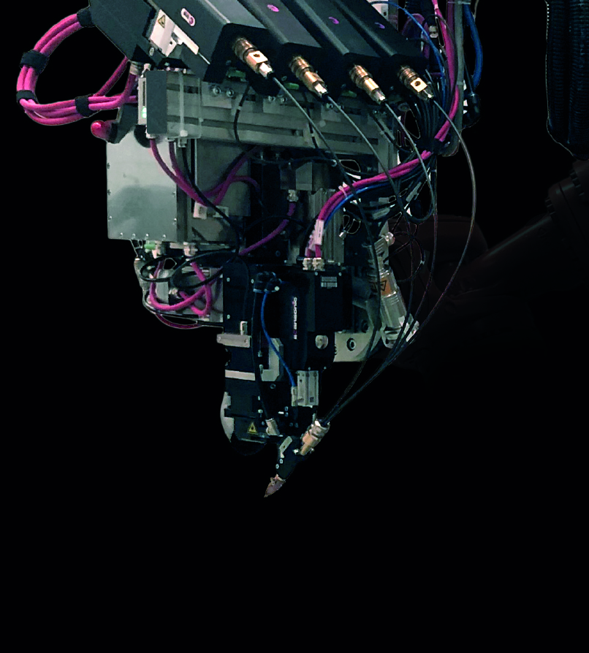
Caption
The new LMWT process uses multiple filler wires, allowing lasers to be employed on thick sheets and large gap widths for the first time.

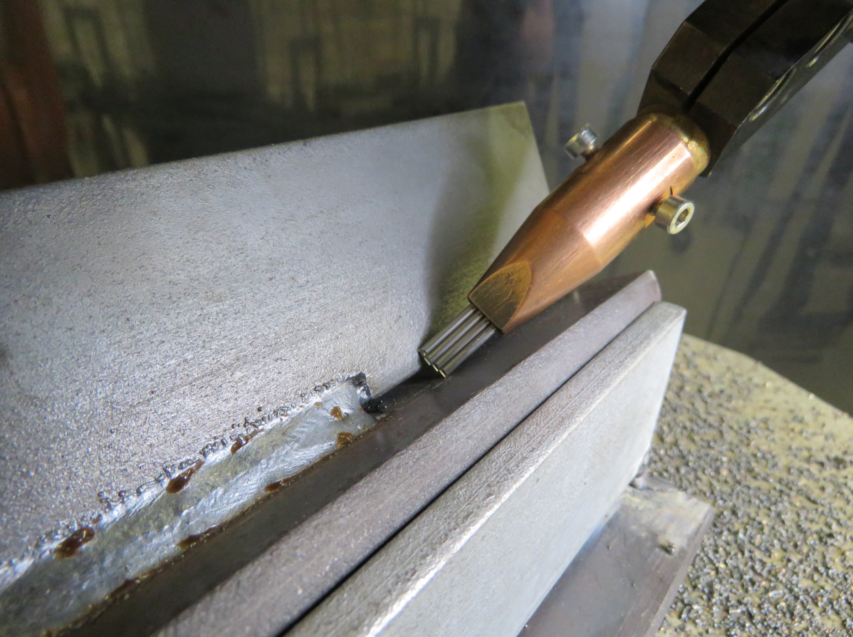
Caption
The new LMWT technology is based on the proven processing head from Scansonic, the market leader in laser-based joining using filler wire. The new process required SKLT to adapt the control system and wire feed so that gaps of up to 3 mm can be bridged.

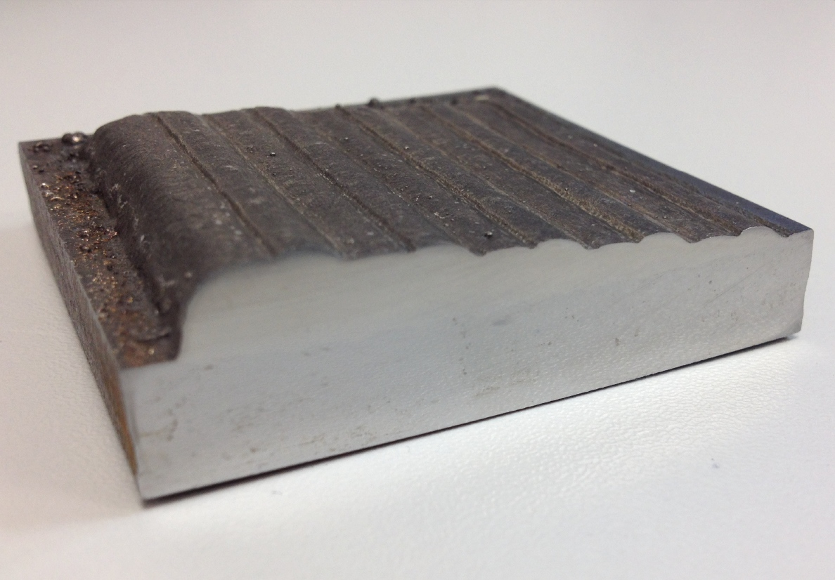
Caption
LMWT allows individual homogenous layers during surface finishing, here: CrNi layers from 1.2 to 7.2 mm on unalloyed steel (10 mm).

Contact:

Company
SKLT Strahlkraft Lasertechnik GmbH l Phone 030-9120 74-630 l info@sklt.de l www.sklt.de

Press
Christiane Herzer | Press and Public Relations | Berlin.Industrial.Group.
T 030-912 074-566 | christiane.herzer@berlin.industrial.group

