LASER World of PHOTONICS | April 26-29, 2022 | Hall 5, Booth A5.311
Product family for cutting optics is expanding
Berlin, February 2022 – Higher laser power allows laser cutting of sheet metal at higher speeds and processing of thicker materials. The resulting increased efficiency in the laser cutting process is in high demand on the market. Scansonic has satisfied this demand by expanding its SCut product family with the new SCut MAX model, designed for laser power up to 30 kW.
The laser cutting optics in Scansonic's SCut series have proven themselves in many applications. Low-drift distance control and an autofocus function ensure high cutting quality. The unit is easy to set up, with horizontal adjustment between laser beam and nozzle regulated by two front-mounted rotary controls. Scansonic has also integrated these design benefits into its new SCut MAX cutting optics, which the company will present for the first time at the LASER World of Photonics trade fair in Munich.
Design adjustments for high power levels
The cutting optics were refined with smart optics design and high-quality optical components to accommodate higher laser power levels of up to 30 kW. In addition, the cutting gas flow was adjusted to the laser power levels and now permits a significantly higher volume flow. The cooling design for the cutting optics was also refined to accommodate the greater heat generation. Larger cooling water conduits and additional cooling elements prevent excessive temperatures from causing damage to the cutting optics. The optics’ autofocus range was also adapted to allow cutting of significantly thicker material. SCut MAX uses an FCH-16 fiber connector for coupling. This connector is suitable for commercially available fiber and disc lasers, and can easily transmit power levels up to 30 kW.
Scansonic has also further enhanced the design of the monitoring sensors for the laser cutting optics in the SCut MAX. Malfunctions are reported immediately to ensure greater overall process safety.
Taken together, these measures produce extremely high-quality cutting results.
Extensive cutting head product family
Going forward, Scansonic will equip all laser cutting optics with a fast fieldbus connection, which will simplify integration into the controller technology used for laser cutting systems. With its new laser cutting optics, Scansonic is expanding its portfolio and now offers the right optics for a wide range of applications. In addition to the SCut 360 for lasers with a large divergence angle and the SCut Pro for laser power up to 12 kW, the SCut MAX now provides a version for higher laser power of up to 30 kW. This permits a robust and stable process for laser cutting of very thick materials or high cutting speeds. More information on the laser cutting optics is available at: https://www.scansonic.de/en/applications/laser-cutting/

(2389 characters, including empty spaces, without header and intro)

About Scansonic MI GmbH
Scansonic offers systems and solutions for laser welding, laser brazing, laser cutting and laser hardening as well as optical sensors and process monitoring systems. The products are used especially in automotive engineering, rail vehicle construction and electrical power engineering. Scansonic MI is the world market leader in laser-based joining systems for car body construction. The company is part of the medium-sized Berlin.Industrial.Group. (B.I.G.) with headquarters in Berlin and around 300 employees. www.scansonic.de

Press contact:  Jörg Lantzsch  Agentur Dr. Lantzsch  Schwalbacher Straße 74  D-65183 Wiesbaden  Tel.: +49-611-205 93 71  E-Mail: j.lantzsch@drlantzsch.de  www.drlantzsch.de | Company contact:  Scansonic MI GmbH  Schwarze Pumpe Weg 16  D-12681 Berlin  Tel.: -+49-30-912074-360  E-Mail: info@scansonic.de  www.scansonic.de  www.berlin.industrial.group

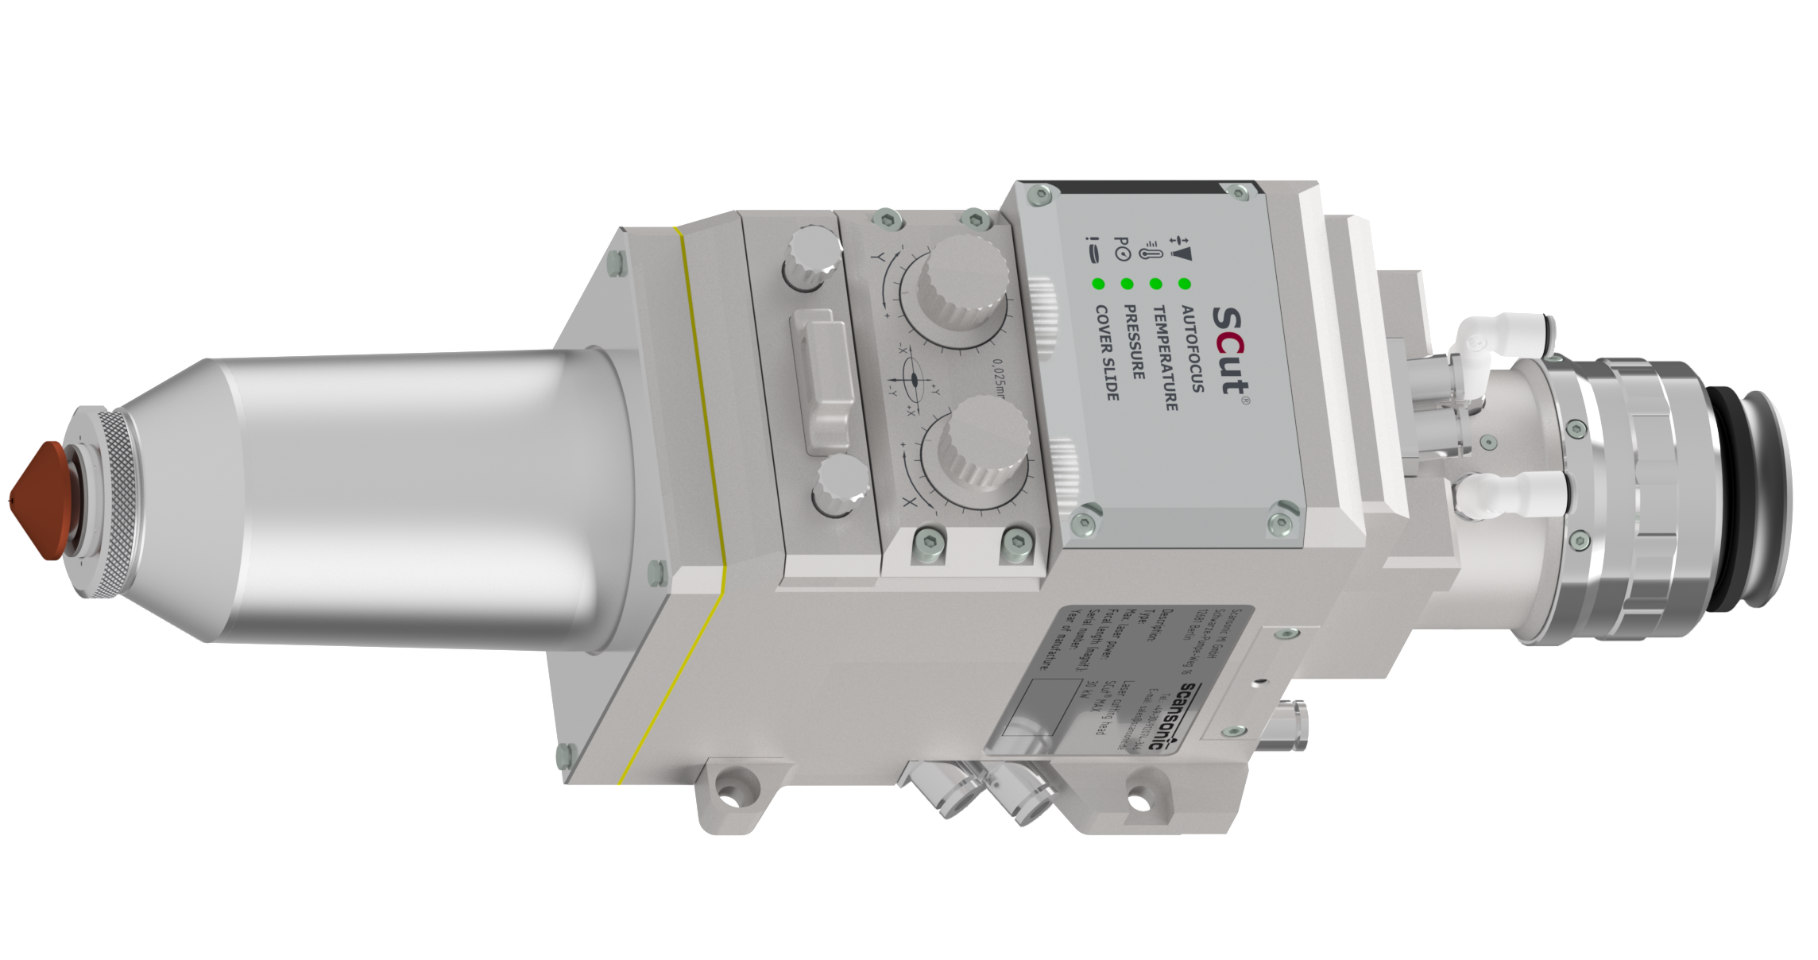
Photo (Scansonic MI_SCut-MAX.png)
Caption: Scansonic SCut MAX – New laser cutting optics enable even greater cutting performance with laser power up to 30 kW.

