GEFERTEC now wholly owned by the Berlin.Industrial.Group.

Berlin, 6 February 2023 – Effective immediately, B.I.G. Holding is the sole owner of GEFERTEC. In a joint decision with founding partners Tobias Röhrich and Georg Fischer, the Group has acquired their shares. B.I.G. Holding had already purchased the shares of EMAG (10 percent) in June of last year.

“This gives GEFERTEC the necessary freedom of action to further expand and solidify its position in the growing market for 3D metal printing,” says Igor Haschke, managing director of GEFERTEC and owner of the Berlin.Industrial.Group. (B.I.G.). Demand for these machines is rising, particularly in the USA.

GEFERTEC offers complete manufacturing systems for metal 3D printing in the Wire-Arc-Additive-Manufacturing (WAAM) process. Therefore, the traditional gas metal arc welding is combined with special process expertise for the additive manufacturing of components, a robust machine system, integrative CAM software and process-related quality assurance. The robust process, high build rates and ease of handling wire as a feedstock make the process interesting for manufacturing medium to large components.

(1,081 characters incl. spaces)

Image: © GEFERTEC

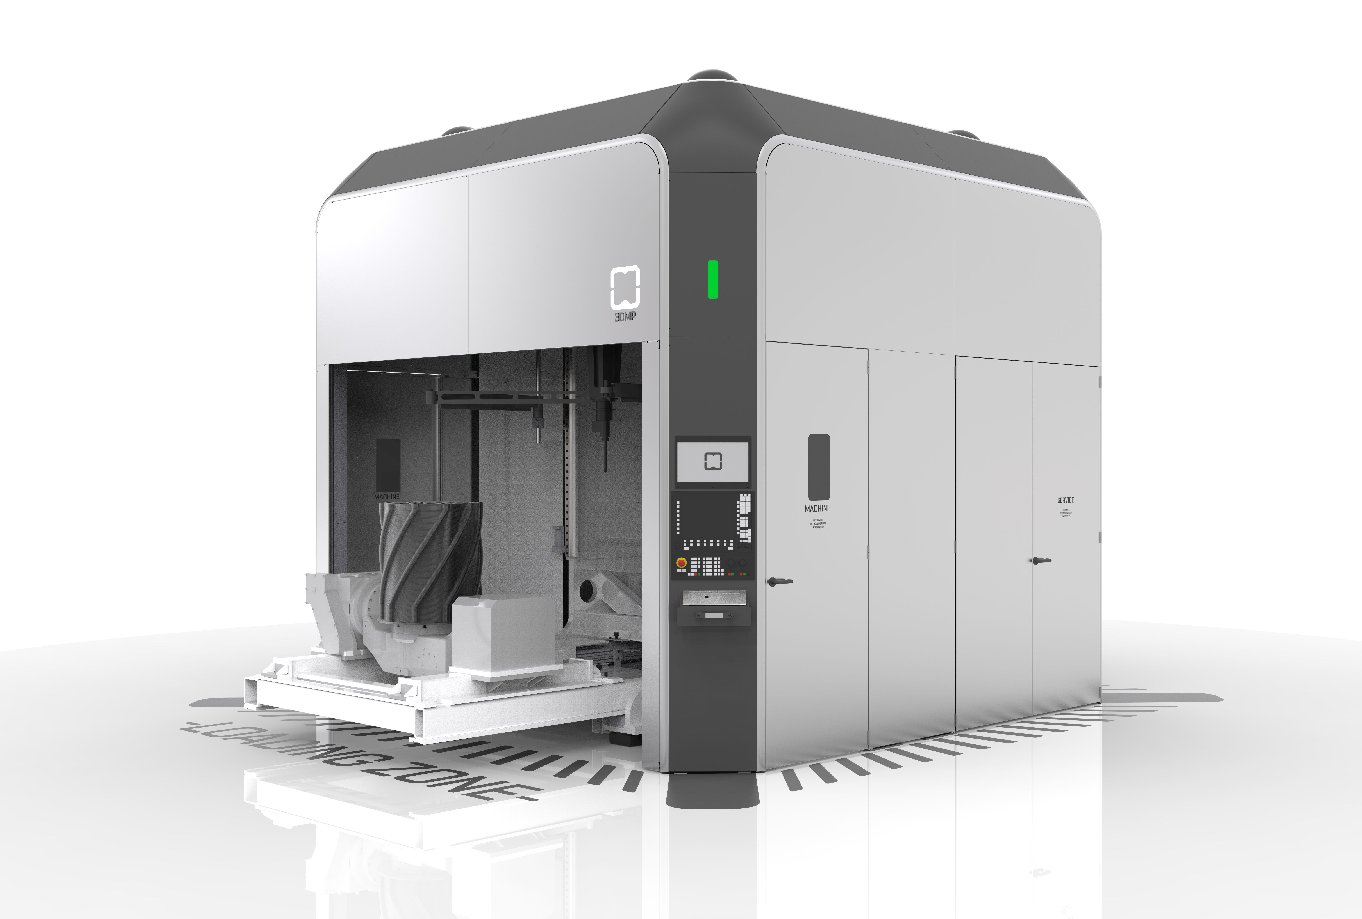
The GEFERTEC arc605 is designed for 5-axis machining of components with a volume of up to 0.8m³ and a maximum mass of 500kg.

About GEFERTEC
Developed by GEFERTEC, 3DMP® is a new process with groundbreaking possibilities for manufacturing metal components. GEFERTEC is the only company in the world to offer this process with state-of-the-art production machinery. The company is a member of the medium-sized Berlin.Industrial.Group. (B.I.G.) headquartered in Berlin with a workforce of approx. 350 employees.

Publication free of charge. Copy requested.

Media contact:  Jörg Lantzsch  Agentur Dr. Lantzsch  Schwalbacher Str. 74  65183 Wiesbaden  Tel.: 0611-205 93 71  E-Mail: j.lantzsch@drlantzsch.de  www.drlantzsch.de | Company contact:  GEFERTEC GmbH  Schwarze Pumpe Weg 16  12681 Berlin  Tel.: 030-912074-360  E-Mail: info@gefertec.de  www.gefertec.de

